Keystone Elk Country Alliance
10thAnnual Pine Creek Chapter
Conservation Banquet
April 23, 2022
Whitneyville Fairgrounds Building & Outdoor Pavilion
Doors open at 1:00p.m. - Dinner at 3:30p.m.

You are cordially invited to attend the Pine Creek Chapter banquet of the Keystone Elk Country Alliance (KECA). This exciting annual event will be held on Saturday, April 23, 2022 at the Whitneyville Fairgrounds building.

Conservation Education continues to be our organization’s number one mission, and the Elk Country Visitor Center continues to drive economic development in our region. In 2020 KECA’s educators delivered programs to more than 41,000 students and guests. We unveiled a Distance Learning Program, bringing the world of elk and wildlife into numerous classrooms across the country. Through our habitat enhancement program, we improved more than 400 acres of habitat for elk and a wide variety of other wildlife.

The banquet promises to be loads of fun with games, activities, and chances to win some fantastic items:
- LIVE and SILENT auctions with many amazing items to bid on, including:
  - A relaxing stay at the beautiful Elk Mountain Homestead, with a date for the weekend of October 28-30, 2022
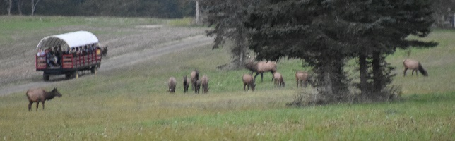
  - An exciting and beautiful horse-drawn wagon ride for up to 22 people at the Elk Country Visitor Center on Sunday, September 11, 2022 at 5:45 pm! This is a 45-minute ride through elk country
- Multiple Firearms giveaways
- Ladies Raffle with tons of beautiful items to win
- Games with fantastic prizes: Plinko, Ducks, Ping-Pong, Mystery Tent, Bingo, Quick Raffle, and more.
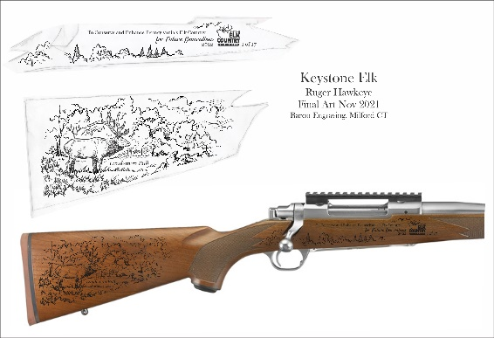
- 50/50 Drawing
One lucky person, at the banquet, will go home with our 2022 Banquet Rifle – Ruger Hawkeye Hunter Rifle 300 Win Mag.

We’ll also have a Sponsor and Life Member drawing for a Kimber 1911 Shadow Ghost Pistol with custom grips featuring an image of an elk. One gun will be given away for every five sponsor or new life members. (If we have 50 sponsors or new life members, we will give away TEN Kimber handguns!)

Take a chance on the Progressive Raffle, where the winner is also entered in a drawing for a once in a lifetime experience! The raffle winner goes home with a Mossberg Patriot Predator Strata Camo with Bronze Cerokote 6.5 Creedmoor with Vortex Senora Scope Package. They are also entered into a drawing, with the other Progressive winners from our other conservation banquets, for a chance to win a guided BULL AND COW elk hunt for two hunters in Chama, New Mexico at Fishtail Ranch!

Please join us on April 23, 2022 to help “conserve and enhance Pennsylvania’s elk country for future generations” and “celebrate ten years of conservation in Elk Country.”

Yours in conservation,

Committee Members:
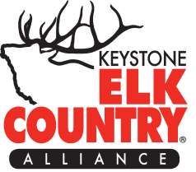
Penny Whipple, Rob McClure, Erisa Ingerick, Terry Bryant, John Coole, Randy Foreman, Martha Chamberlain, Clifford Cross Jr., Bonnie Roupp, Pete McClure, Ron Signor, Penny & Dave Robinson, Kristi & Daryl Derbyshire

